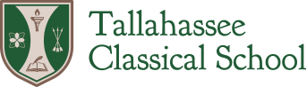

Board of Trustees
Special Meeting Minutes

December 19, 2022
6:00 pm
At Tallahassee Classical School

- Roll Call / Call to Order: Present and constituting a quorum: Barney Bishop, III, Pam Griggs, Matt Mohler, Tim Qualls

Also Present: Pat Hoy, Casey Diehl, Judd West, Monty Starke, J. Smith.

- Motion to leave name of School House (Lupus) alone and for the Board not to get involved in regulating this aspect of campus life. Tim Qualls, Pam Griggs. MOTION CARRIED

- Motion for the design build team to provide a Scope of Work and proposed contract for the Master Planning and Programming by the January Regular Meeting. Tim Qualls, Matt Mohler. Motion Carried.

- Adjourn

